Getting Started Guide for EARLY ALERT
Faculty & Staff

Welcome to Starfish®
Starfish gives you a convenient way to keep track of your students – raising flags when you observe a pattern of behavior that concerns you, ensuring that the people on campus who can intervene are aware.
Getting started is easy. Accessible through Drake’s existing systems, Starfish will automatically display all students that you have been assigned or are enrolled in your courses.
The link to Starfish is located on the MyDrake portal in two places:
- Faculty and Advising section
- Administrative Tools section

After clicking on the Starfish link on myDrake, one of two things will happen.
- If you have not already accessed an application using Single Sign-On, you will receive a login screen and need to enter your Drake credentials. User name can be either your Drake ID# or your Drake email address.

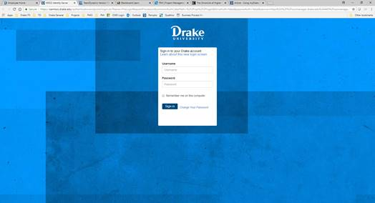
2. If you have already accessed an application using Single Sign-On and entered your Drake credentials, you will be taken directly to Starfish (no credential entry and login required).

This guide highlights the steps for completing 3 common tasks in Starfish EARLY ALERT:
- Setup your Profile 3
- Respond to a Progress Survey for students in your courses 4
- Raise a Flag on one of your students 5

Frequently Asked questions 6
How do I get more detail on a student? 6
How do I change how I am emailed by Starfish? 6
Where can I find information about flags raised on my students? 6

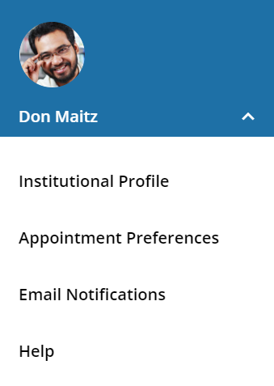
Setup your Profile
Some of your profile, such as your contact information, is imported from your LMS or SIS. You have the ability to edit other parts of your profile, such as your biography.
- Click on your name in the Top Navigation bar and select the Institutional Profile tab.
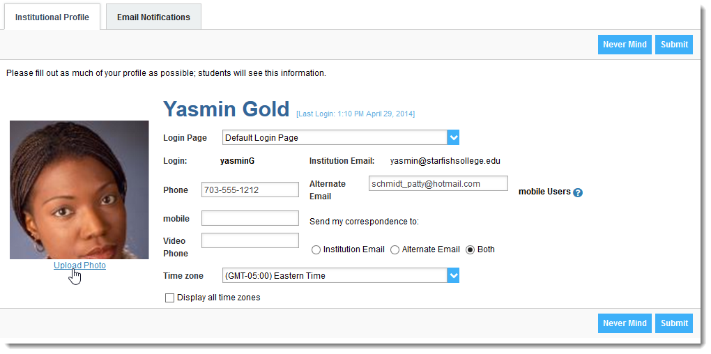
- Double check that the Time zone selected matches your time zone. This time zone will be used when including appointment times in emails from Starfish.
- Help students put a face to your name by clicking the Upload Photo link beneath the existing photo or photo placeholder.
Browse to a photo file (.jpg, .png, or .gif), and then click the Upload Now button to update your photo.
- Click the Submit button to save your changes.
Notes:
You may find the following Starfish Two Minute Tips helpful:
- Update your Starfish Profile
- Update how you are emailed about Flags

Respond to a Progress Survey for students in your courses
You will receive an email reminder when there is a new survey for you to complete. Each individual survey presents a student roster for one course section on whom you can raise flags.
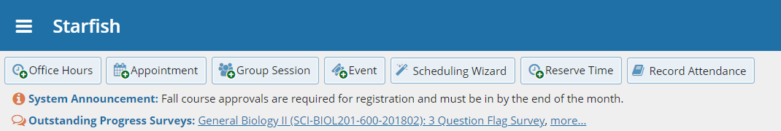
- Select the progress survey link on your Starfish Home page to go the Progress Surveys tab. (only visible when you have active surveys).
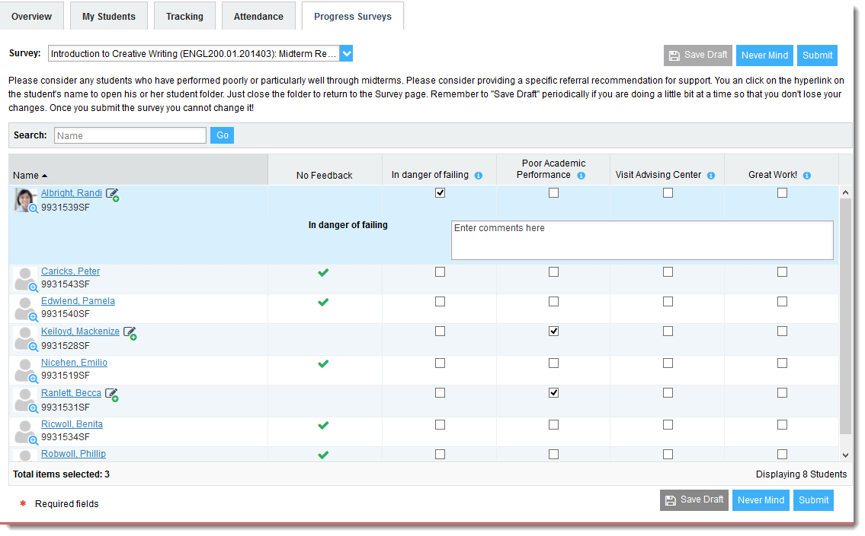
The selected survey opens, listing your students on the left, and items you may raise across the top.
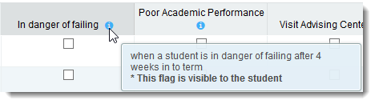
- Check the box for each desired item/ student combination.
Click the comments icon () to open a text box for your notes.
Click the information icon () associated with an item to verify whether or not the student can view the flag and related comments.
- Click the Submit button only when you are finished providing feedback. The items you selected will be raised on your students when you submit the survey.
Important
Once you have submitted the survey, you will not have an opportunity to add to or undo the items you raised. Use the Save Draft option if you aren’t ready to submit your survey.

Notes:
You may be asked to submit more than one course survey if more than one of your courses has been included in the survey plan for your institution. They will be listed in the drop-down menu on the Progress Surveys tab.
Watch the Two Minute Tip on completing a progress survey for a demonstration of this feature.

Raise a Flag on one of your students
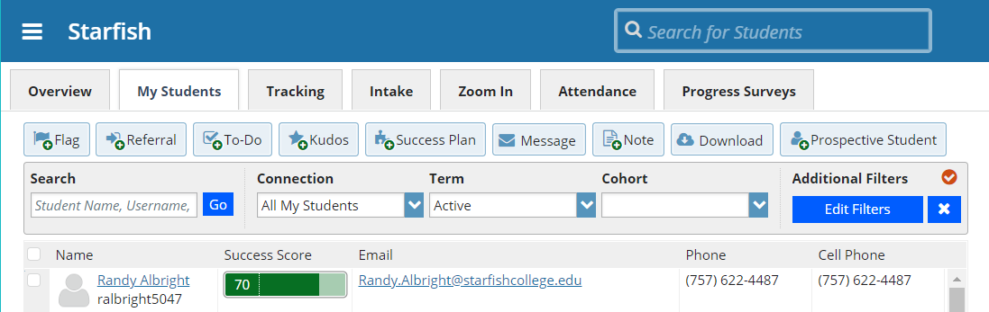
When you have a concern with a particular student, raise a flag, to-do, or referral to communicate your observations. The appropriate individuals will be automatically notified when you save the item.
- Click on the Students navigation item to see your list of students.
- Find the desired student by typing the name into the Search box.
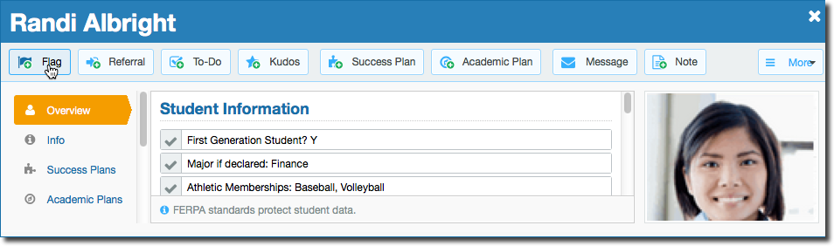
- Click on the student’s name to bring up the Student Folder.
- Click the Flag button.
A list of flags that you have permission to raise on this student is displayed.
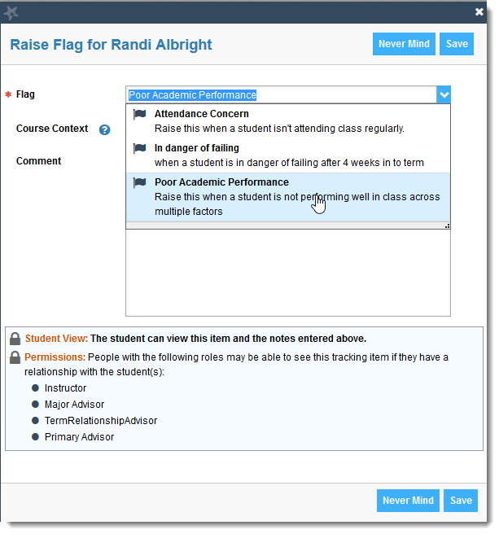
- Select the desired Flag from the list.
- If relevant, select a course from the Course Context, drop down list, and enter notes in the Comment box.
- Click the Save button.
Notes:
The Student View: indicates whether the student can view the flag and the notes you include in the Comment box.
The Permissions area lists roles that have permission to view the selected flag and the notes you include in the Comment box.

Frequently Asked Questions

How do I get more detail on a student?
Anytime you see a student’s name as a hyperlink (e.g. in your student list, on an appointment, or in a progress survey) this hyperlink takes you to the Student Folder.

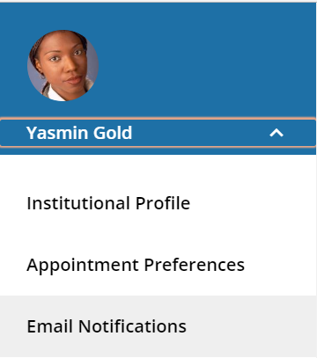
How do I change how I am emailed by Starfish?
Starfish will email you a calendar item for each appointment and a summary of flag activity for your students. Use the Email Notifications tab of your Profile to modify details of how and when you receive these notifications. For more information see this Two Minute Tip: Update how you are emailed about Flags

Where can I find information about flags raised on my students?
The Tracking tab within the Students area lists the flags (and kudos) that have been raised on your students. Use the filters provided to filter your list based on your connection to the students. For example you can filter to your role as advisor vs. your role as instructor, or as an instructor to one of your specific course sections.
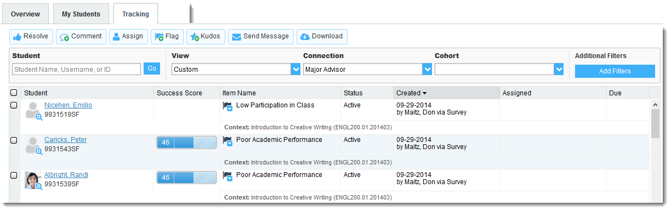
You can also go into the individual Tracking tab of any Student Folder to look at details of flags raised on that student. The details of what you see are based on your relationship to the student(s) and the privileges granted to your role.

